
KKR & KSR INSTITUTE OF TECHNOLOGY & SCIENCES Approved by AICTE, New Delhi | Affiliated to JNTU, Kakinada
Accredited by NBA & NAAC

NATIONAL WORKSHOP
on
RETOOLING LANGUAGE TEACHING TO THE STUDENTS OF PROFESSIONAL COURSES
1st, 2nd & 3rd November, 2K18
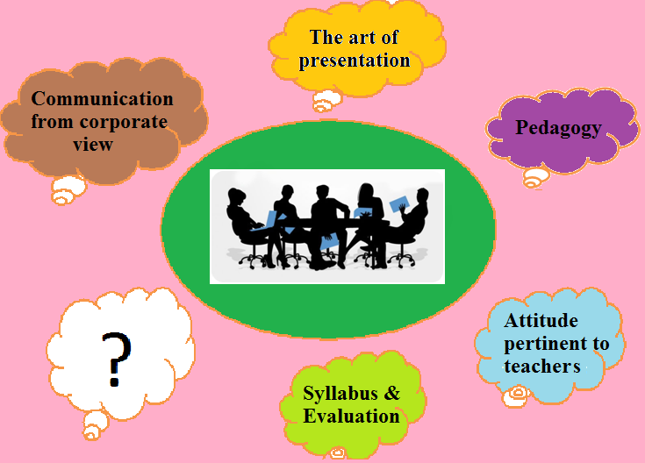
Organized by
The Dept. of Science & Humanities
KKR & KSR Institute of Technology & Sciences
Vinjanampadu(V), Vatticherukuru(Md), Guntur, A.P - 522017
www.kitsguntur.ac.in
Mail: kitsengws2k18@gmail.com
Ph:-0863-2286666/77
About KKR & KSR Institute of Technology & Sciences
KKR & KSR Institute of Technology & Sciences, a pioneering institute in the capital region of Andhra Pradesh is located amidst serene environment at Vinjanampadu Village of Vatticherukuru Mandal, 5 km away from Guntur. Since its inception in 2008 the institute has been marching ahead with thunderous achievements. From a modest intake of 240 students the institute is now a potential one offering quality education to the students over 3000 with a provision of quality infrastructure.
KITS offers UG programmes in the Departments of CSE, EEE, ECE, Mechanical and Civil Engineering. The institute is accredited by NBA and NAAC and is permanently affiliated to JNTUK.The institute also offers PG programmes in MBA, M.Tech (CSE), M.Tech (VLSI), M.Tech (DECS).
With an emphasis on innovation and by adopting latest technologies to improve life, KITS encourages research, conferences, seminars, workshops, technical fests and hackathons which resulted in 10 start-ups from intellectual brains within the campus. The institute leaves no stone unturned to enable the students and the staff reach their goals. It creates unbounded space for one to grow to one’s fullest potential. Every year about 500 students are being placed in corporate organizations. Besides others there have been 92 placements in Capgemini, 13 in TCS so far during this semester.
About S & H Department
The department of Basic Sciences and Humanities in KKR & KSR Institute of Technology and Sciences is synthesized with dedicated team of faculty members, quality infrastructure, fully equipped laboratories and good facilities.
The department is a unique combination of multiple disciplines of thought like Languages, Mathematics, Physics, Chemistry, Environmental Studies, Professional Ethics, Physical Education, Library and Management Studies. It offers necessary training to the students to enhance their communication skills by organizing English language clubs. The department engages in orienting the freshers for a successful college career and imbibes in them the qualities of continuous learning. The members of the department effectively contribute to all the activities belonging to the student clubs, literary and cultural events.
The department also offers training in life skills, verbal reasoning, arithmetic for campus placements etc. The department firmly believes that a good foundation is the life for a huge structure. A well-disciplined career builds up the character. The department works towards realizing this truth.

Objectives of the Workshop
Language refines, civilizes, empowers, humanizes…! Human learning begins before birth and continues till death as a consequence of ongoing interactions between person and environment.
Sea changes have swept the education system across the globe. Today, the focus is on learner-centric education. The teacher – student relationship is not that of a boss and a subordinate or that of ‘a respectable guru and an obedient shishya’. The ever cheerful, empathetic and inspiring teacher needs to be a friend, philosopher and guide.
“I cannot teach anybody anything. I can only make them think” – Socrates
As a facilitator of learning, a teacher helps students in acquiring new or modifying existing knowledge, behaviors, skills, values or preferences. Precisely these are the objectives of the workshop. Let us think out of box, share our ideas, experiences and thereby empower ourselves and our students.
Topics
- Attitude Pertinent to Teachers of Professional Courses
- Pedagogy Related to Language Teaching to Students of Professional Courses
- Communication from Corporate View
- The Art of Presentation of Content
- Syllabus and Evaluation Systems

RESOURCE PERSONS
1. Dr.A.S.Rama Krishna
2. Dr. K. Suresh Kumar
3. Dr. G. Chenna Reddy
4. Dr. P. Yamini
5. Dr. Sk. Shabree Sultana
6. Prof. P. Gopichand & Prof. P. Naga Susila
7. Mr. K. Prabhakara Rao
How does each session proceed?
Each session proceeds in two time slots
Slot 1: Each topic is discussed in groups by the participants. Then, the participants share their opinions, experiences and strategies pertaining to the topic with other groups.
Slot 2: The Resource person deals with the topic and then interacts with the participants.
Registration Form
Registration Fee : Rs. 300/-
Name of the Participant :
Designation :
Mobile No. :
Email ID :
Name &
Address of the Organization :

Date:
Place:

Signature of Signature of the the Principal Participant
Participants are requested to mail the filled in form to the following
Email ID: kitsengws2k18@gmail.com
Who can attend?
- Faculty of professional institutes
- Aspirants
For registrations and details please contact:
- Ms. Pavani Gonnuri - +91 8500244671
- Mr. Y. Ramu - +91 7382731230
ORGANISING COMMITTEE
CHIEF PATRONS
Sri Koye Subba Rao, Chairman
Sri Koyi Sekhar, Secretary
PATRON
Dr. P. Babu, Principal
CHAIR PERSON
Prof. M. Basaveswara Rao, +91 9441185032
HOD, Dept. of Science & Humanities
CONVENORS
Dr. N. Aravind, Prof. of English,
+91 9490187628
Mr. M. Nageswara Rao, Asst. Prof. of English,
+91 9885427024
MEMBERS
Ms. Pavani Gonnuri
Mr. Ramu Yarlagadda
Mr. V. Srinivasa Rao
Mrs. A. Sirisha
Mrs. N. Ram Devi
Mr. N. Suresh
Mrs. I. Vidya Rekha

